Square

Creating the developer acount. Go by link: <https://squareup.com/signup?return_to=https%3A%2F%2Fconnect.squareup.com%2Fapps&v=developers>

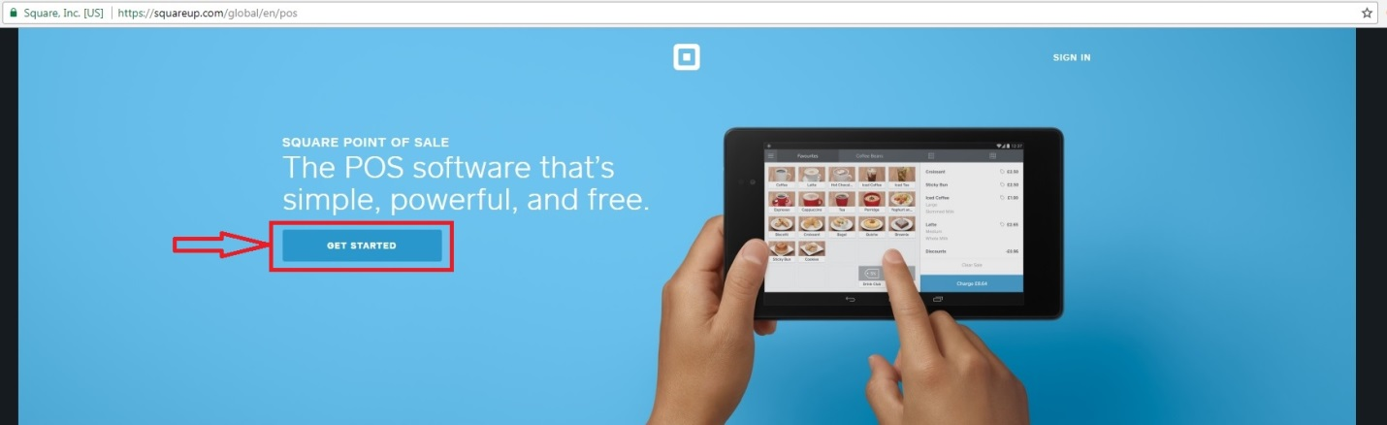

1. Fill information for sing up.

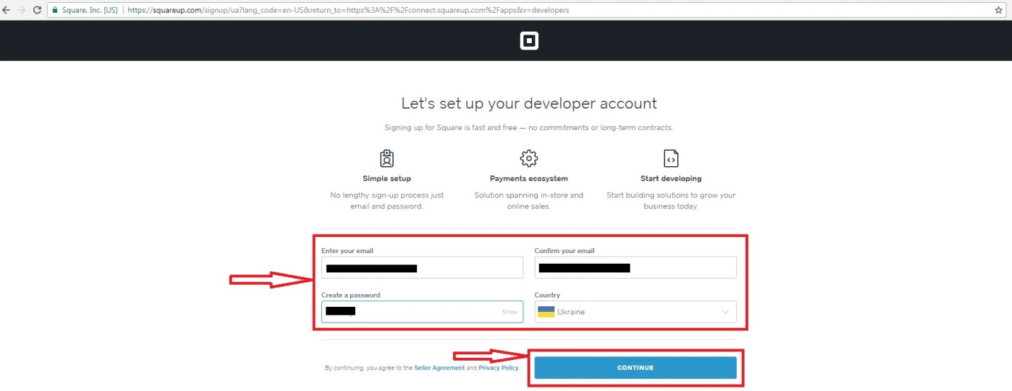

1. At Application dashboard choose "+New Application". Input application name and press "Create application" button.

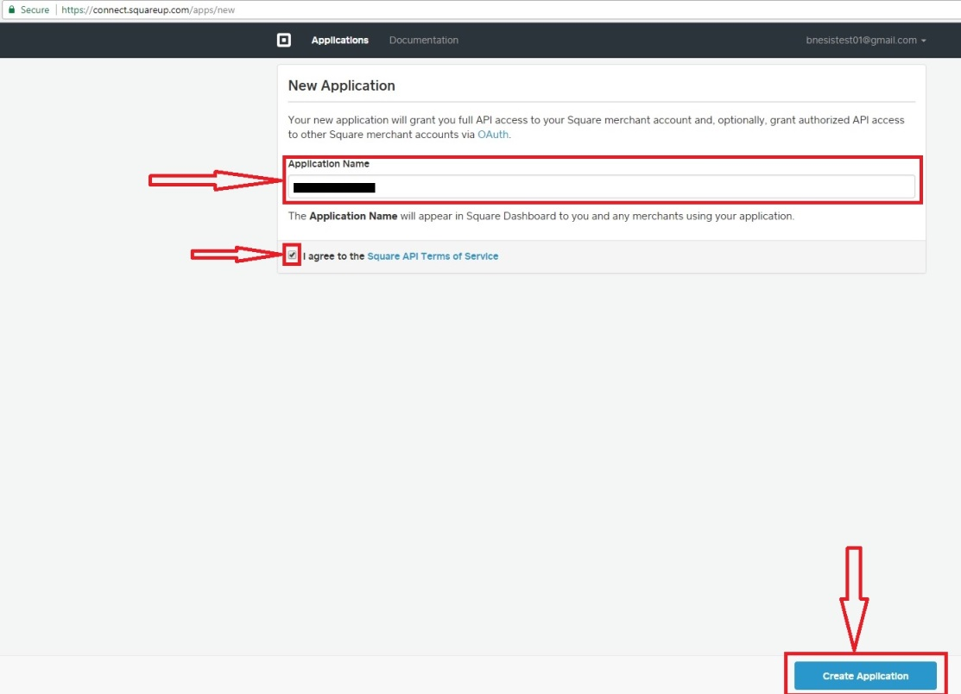

1. In the Credentials page Application ID and Personal Access Token appear.

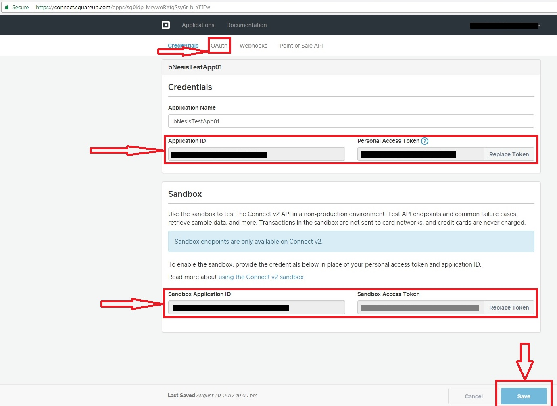

1. In the OAuth page Application Secret appears

